**Experiment No:** 02

**Experiment Name:** Introduction to HTML and Its basic elements.

**Theory:** HTML, or Hyper-text Markup Language is the standard markup language used to create web pages. It is a combination of Hypertext and Markup language. The Hypertext defines the link between web pages, and Markup defines the text document within tags to structure the web pages. This language annotates text so that machines can understand and manipulate it accordingly. HTML is human-readable and uses tags to define what manipulation has to be done on the text.

**Source Code:**

<!DOCTYPE html>

<html lang="en">

<head>

<meta charset="UTF-8">

<meta name="viewport" content="width=device-width, initial-scale=1.0">

<title>Good Food.</title>

</head>

<body>

<center><img src="pancake.jpg" height="250" width="600"></center>

<center><b><font size=25><i><font color=dark orange>Perfect Pancakes Recipe</font></i></font></b></center>

<hr>

<h2><i><u><font color=green>Ingredients</font></u></i></h2>

<ol type="i">

<h3><dd><li><em>100gm plain flour.</em></li></dd></h3>

<h3><dd><li><em>2 eggs.</em></li></dd></h3>

<h3><dd><li><em>300ml semi-skimmed milk.</em></li></dd></h3>

<h3><dd><li><em>1 tbsp sunflower oil or vegitables,plus extra for frying.</em></li></dd></h3>

<h3><dd><li><em>Pinch salt.</em></li></dd></h3>

</ol>

    <h2><i><u><font color=green>Method</font></u></i></h2>

<h3><i><dd><u><font color=purple>Step 1:</font></u></dd></i></h3>

<h3><P><em><dd>Put 100g plain flour, 2 large eggs, 300ml milk, 1 tbsp sunflower

or vegetable oil and a pinch of salt into a bowl or large jug, then whisk to a smooth batter.

This should be similar in consistency to single cream.</dd></em></P></h3>

<h3><i><dd><u><font color="purple">Step 2:</font></u></dd></i></h3>

<h3><p><em><dd>Set aside for 30 mins to rest if you have time, or start cooking straight.</dd></em></p></h3>

<h3><i><dd><u><font color=purple>Step 3:</font></u></dd></i></h3>

<h3><p><em><dd>Set a medium frying pan or crêpe pan over a medium heat and

    carefully wipe it with some oiled kitchen paper.</dd></em></p></h3>

<h3><i><dd><u><font color=purple>Step 4:</font></u></dd></i></h3>

<h3><p><em><dd>When hot, cook your pancakes for 1 min on each side until golden, using around half a ladleful

     of batter per pancake. Keep them warm in a low oven as you make the rest.</dd></em></p></h3>

<h3><i><dd><u><font color=purple>Step 5:</font></u></dd></i></h3>

<h3><p><em><dd>Serve with lemon wedges and caster sugar, or your favourite filling. Once cold,

you can layer the pancakes between baking parchment,

 then wrap in cling film and freeze for up to two months.</dd></em></p></h3>

<h2><i><u><font color=green>Freezing</font></u></i></h2>

 <h3><p><em><dd>Freezing pancakes is a great way to enjoy them later. Cool the pancakes completely on a wire

 rack to prevent condensation. Then, place a sheet of parchment or wax paper between each pancake and

stack together. Wrap the stack of pancakes tightly in aluminum foil or place inside a heavy-duty freezer

 bag. To reheat, place them in a single layer on a baking sheet and cover with foil. Bake in a 375°F-oven

for about 8 to 10 minutes, or until hot.</dd></em></p></h3>

<h2><i><u><font color=green>Variations</font></u></i></h2>

<h3><p><em><dd>You can personalize your pancakes with a variety of mix-ins. You can also flavor the batter with

 vanilla extract or citrus zest for added depth. It’s often best to dot the add-ins like blueberries, chocolate

 chips, or banana slices directly onto the pancakes after you’ve poured the batter into the skillet.

 This approach allows for more even distribution and prevents the heavier items from sinking

  to the bottom of the bowl.</dd></em></p></h3>

 <h2><i><u><font color=green>Nutrition</font></u></i></h2>

 <h3><p><em><dd>Calories: 156kcal | Carbohydrates: 22g | Protein: 4g | Fat: 6g | Saturated Fat: 3g | Polyunsaturated Fat: 0.3g |

 Monounsaturated Fat: 1g | Trans Fat: 0.2g | Cholesterol: 30mg | Sodium: 311mg | Potassium: 84mg | Fiber: 1g | Sugar: 6g |

  Vitamin A: 198IU | Calcium: 129mg | Iron: 1mg</dd></em></p></h3>

<h3><i><u><font color=red>Tips for how to make easy pancakes</font></u></i></h3>

<ol type="i">

<h3><dd><li><em>You need a good non-stick pan to avoid any bits getting left behind. It also means you don't

have to keep wiping the pan with oil before cooking each pancake.</em></li></dd></h3>

<h3><dd><li><em>The batter is supposed to be thin as it’s a classic pancake mix.</em></li></dd></h3>

</ol>

<h3><p>Visit<a href="https://www.bbcgoodfood.com/recipes/easy-pancakes"> to know more about easy pancakes recipes.</a></p></h3>

</body>

</html>

**Output(compilation,debugging & testing):**

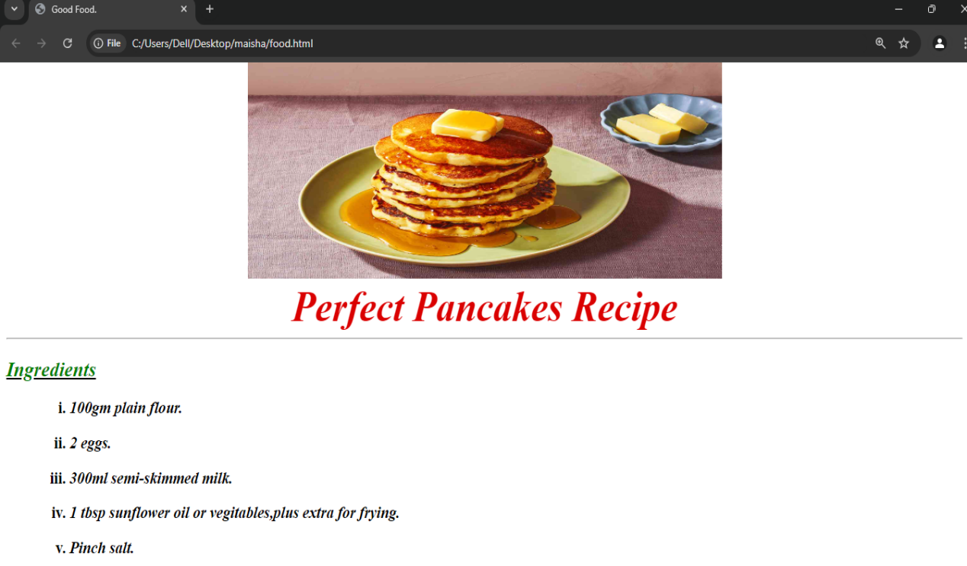

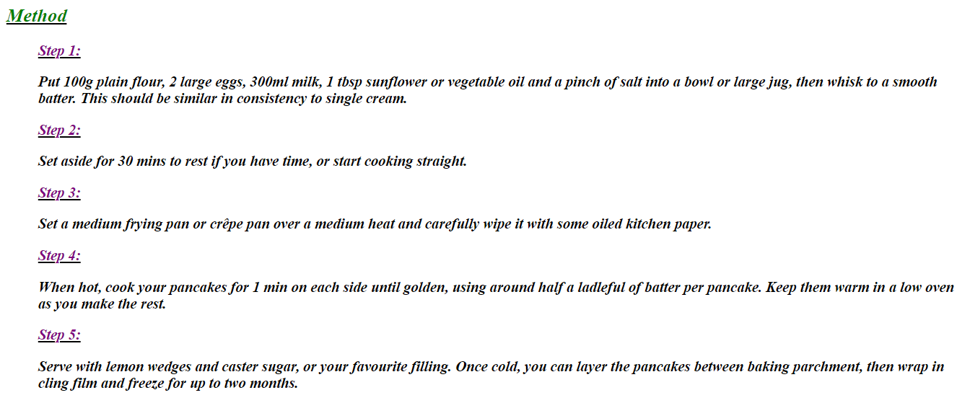

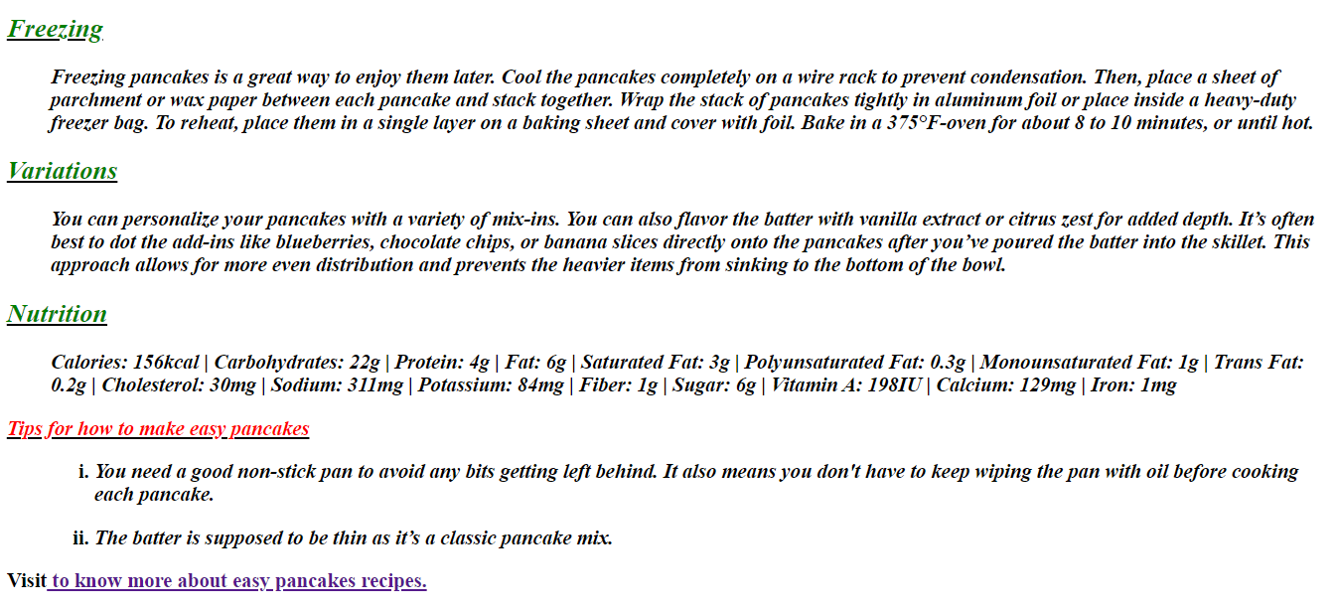

**Discussion**: From this lab session,I got to learn how to create a website using HTML and necessary tags.So I created a “Good Food” website.In developing the website.I used basic HTML tags to structure the content and create a functional layout which we learned at our lab.I used block-level elements such as headings <h1>,<h2>…<h6> paragraphs <p>,lists <oi> etc.Images were centered using <center><img src=””.For better structure I used emphasize <em> and line break <br>.When I was creating my web page by using HTML tags ,I had to face some little problems but after that I was successful to create my web page “Perfect Pancakes Recipe”.There I showed how to make a perfect pancake. At last,in future by using those knowledge ,we can create more and more our own web page.